1NF

1NF : According to 1NF a table should not contain any multi valued attribute.

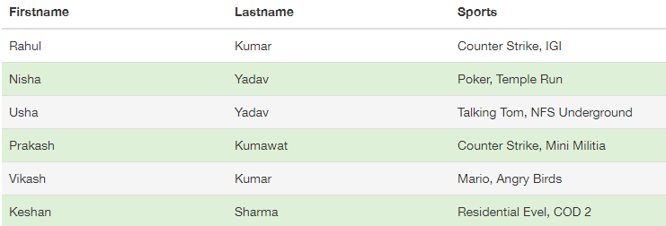
Table: User Table before 1NF

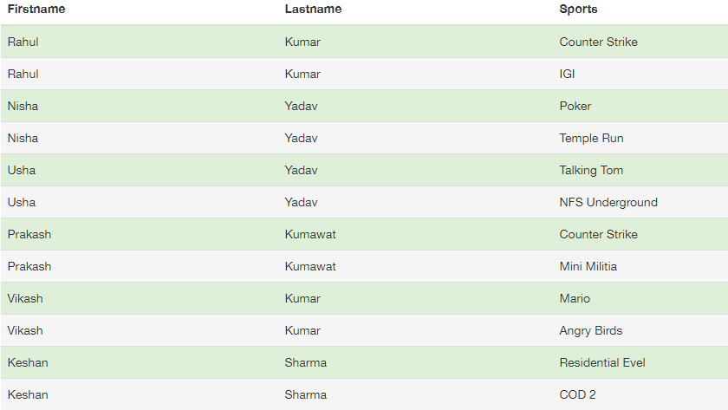
Table: User Table after 1NF
so, to change a relation in 1NF the following condition must be satisfied :
All the attributes have single valued attributes. If any tuple have multivalued attribute than split it in two or more tuples.

2NF
2NF : According to 2NF Every non-prime attribute must be fully dependent on prime attributes or we can say partial dependency is not allowed.
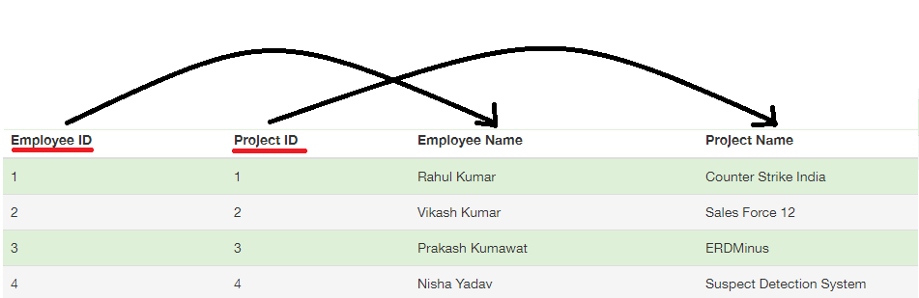
Table : Employee Table Before 2NF

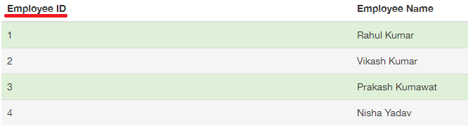
Table : Employee Table After 2NF
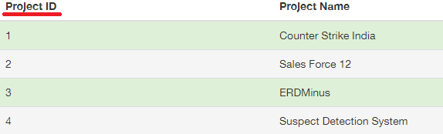
Table: Project Table After 2NF

so, if any non-prime attribute is partial dependent on prime key then spilt the table in two or more then two tables.

3NF
3NF : according to 3NF any non-prime attribute not have any dependency on any non-prime attribute. Or there shouldn't exist any transitive dependency.

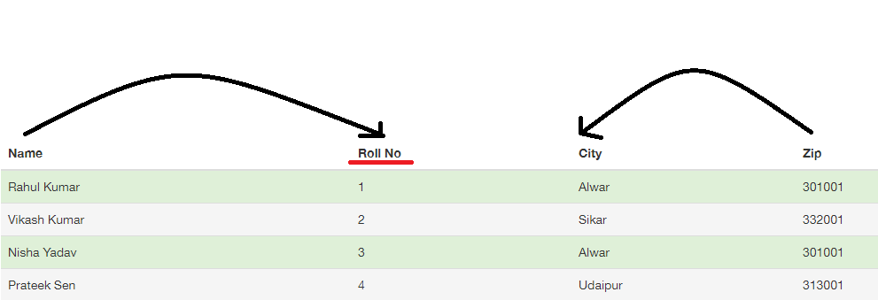
Table : Student table before 3NF

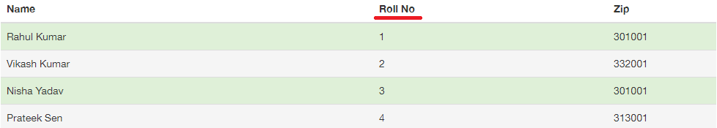
Table : Student table After 3NF
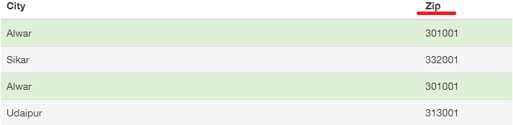
Table : Zip table after 3NF

So, to make table 3NF suitable we have split the table in two. Because in student table city depends on zip which is an non-primary attribute.

